**Home Page About Us Specialist Services Software Applications Our Partners Join Our Team Contact Us References/Support/Download**

**Home Page**

**WELCOME TO SEFCOM ENVIRONMENT**

SECOM Environment is a highly specialised and skilled environmental, engineering, and groundwater consulting company dedicated to deliver world class products to our clients. SEFCOM Environment prides itself in providing clients with a blend of traditional Environmental and Engineering Solutions complemented with current dynamics and technologies. We are the benchmark of quality within our industry with innovative, diversified Environmental and Ground Engineering Specialists in Africa. The company works closely with a trusted and accredited professional network of leading specialists, ensuring that a wealth of knowledge and innovation is brought to each customer experience.  
The company enjoys a staff complement of committed, highly trained, specialized and skilled professionals of international reputation.

FOR YOUR NEXT PROJECT, SEFCOM ENVIRONMENT IS YOUR 4IR PARTNER!

**ABOUT**

SEFCOM Environment was established in 2018 to deliver and expand professional environmental and groundwater consulting in Ghana and Africa. The company is highly specialized and offers clients individual services worldwide backed by a wide range of expertise.

We apply our expertise to a wide client base including the mining, government, institutional, agricultural and industrial sectors (locally and internationally). Our specific expertise includes hydrogeological (and seepage) modelling, groundwater management, geochemistry, hydraulic plume containment, groundwater supply, spatial data analysis and environmental/ groundwater training, engineering and environmental services.

**OUR GOAL**

Our goal is partnership with our clients to provided the highest quality of services and to maintain high levels of professional ethics towards the fourth industrial revolution and beyond. We are enthusiastic about the implementation of modern technology and artificial intelligence.

**SPECIALIST SERVICES**

**ENVIRONMENTAL**

Environmental Impact Assessment

Environmental Sensitity Analysis and Mapping

Environmental Planning

Land-use Planning

GIS Spatial Modelling

Soil Studies and Analysis

**WATER**

Hydrogeological Modelling

Geophysical Investigations

Seepage Modelling

Groundwater Management

Geochemistry

Hydraulic Plume Containment

Groundwater Supply

Spatial Data Analysis

Floodline Mapping

Surface Water Baseline and Impact Assessment

Development of Stormwater management Plans and Audits

**ENGINEERING**

Agricultural Systems

Mining

Oil and Gas

Particle Separation Systems

Software Development

Design of Industrial Jets for discharging industrial effluent

Design of clinical drug inhalation devices

Pneumatic conveying systems

Design of Toilet and Sanitation facilities

**RESEARCH**

SEFCOM Environment is in the forefront with many academic institutions, industry, government and non-governmental organizations, United Nation organizations, and private sector in the field of research and development toward sustainable developments goals. We collaborate in the area of agriculture, water, climate change, environment, sanitation, and energy.



**TRAINING**

SEFCOM Environment provide wide range of environment, engineering, hydrogeological training in the public, private and industrial sector in many countries.



**SOFTWARE APPLICATIONS**

HYDRUS

MODFLOW

FEFLOW

GOLDSIM

PHREEQC

ArcGIS

QGIS

CFX

ANSYS

DYNAMIC STUDIO

Hydrus

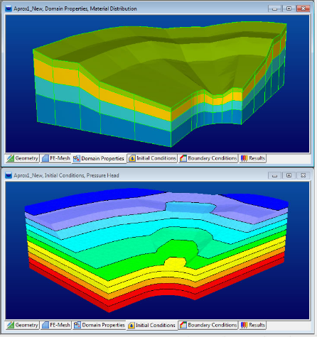

**OUR PARTNERS**

 

 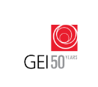

**Interested in Partnerships?**



**JOIN OUR TEAM**

Thank you for your interest be part of Sefcom Environment Limited. At Sefcom Environment, we seek creative and career-oriented employees who will strengthen our market presence. If you like to be a part of our family, contact us to join a team that shares a vision of excellence. To submit your resume, please send an email to: [info@sefcomenvironment.com](mailto:info@sefcomenvironment.com)



**CONTACT US**

Tel: +233 24 5142414, +233 20 8833034

EMAIL: [info@sefcomenv.com](mailto:info@sefcomenv.com)

POSTAL ADDRESS: P.O. BOX TF330, ACCRA, GHANA

PHYSICAL ADDRESS: 10 OFFIN STREET, KWABENYA, ACCRA, GHANA.

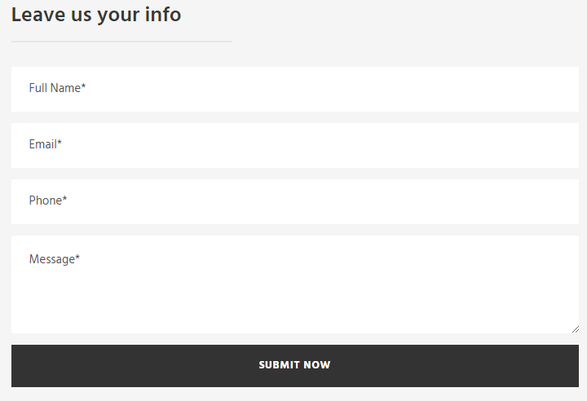

**REFERENCES/SUPPORT/DOWNLOAD**